Order Of Service

Singing: Psalm 78—CW page 95

Reading: Psalm 39

Opening Hymn: TLH 243

Reading: Acts 1:1-11

Request Hymn: CW Supplement 769

Reading: John 9:24-34

Sermon Hymn: TLH 446

Sermon Text: Song Of Solomon 6:13

Return x 4

Prayer

The Apostles’ Creed, TLH page 12

Holy Communion

The Lord's Prayer

The Blessing

Closing Hymn: TLH 447

* * * * * * * * * * *

Bible Study: Lambs: Worms
Sheep: Proverbs 14:31-35


Returning Home

Water
Of
Life

28 May 2017

W A T E R O F L I F E

Independent Christian Church—Conservative Lutheran Doctrine

Worship Service: 9:30 a.m. Bible Study: 10:45 a.m.

Larry Cooper, Pastor E-Mail address:
111 N. Ridge Road lcooper@wateroflife.cc
Coon Valley, WI 54623 Web Site:
Phone: (608) 452-2105 www.wateroflife.cc

* * * * * * * * * * * * * * * * * * * * * * * * * * *

Sermon Text: Song Of Solomon 6:13

Return, Return, Return, Return

* * * * * * * * * * * * * * * * * * * * * * * * * * *

Song of Solomon 6:13 Return, return, O Shulamite; return, return, that we may look upon thee. What will ye see in the Shulamite? As it were the company of two armies.

The Long Journey Back Home

When the prodigal son left the home of his father, the Holy Spirit tells us that he “took his journey into a far country.” So have we all. It all started in Eden’s Garden. And as the poet says—“In Adam’s fall, we sinned all.” This includes the elect Bride of Jesus Christ.
Being that this is the case, it follows that we also have a long journey back home. It is an extremely difficult journey, filled with dangers and hardships.

But we have a lot going for us.

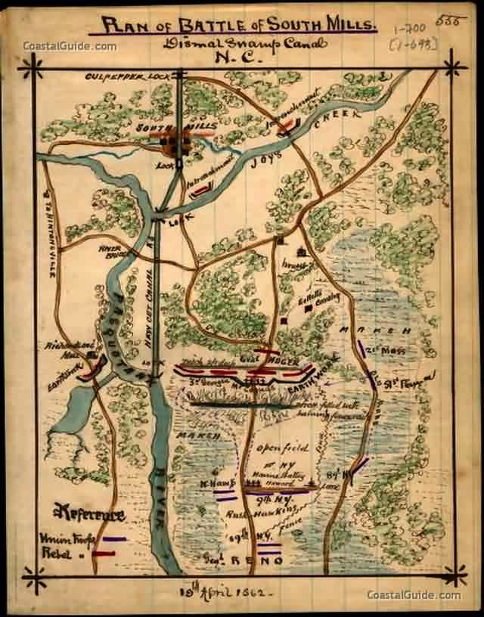

Here in Song Of Solomon 6:13, the Bridegroom urges his Bride—“Return! Return! O Shulamite; Return! Return!” This is a loving command. Notice the “double-double” emphasis here! The Bridegroom urges his Bride to come back home.

The Holy Spirit, dwelling within the Bride, works obedience in her heart. And moves her to obey this loving command. And then preserves her through his word, and brings her back home.

